## CS 135I - Week 1 Activities

### Getting Ready

Complete the online readings from this week’s Moodle unit, ideally *in advance* of our class meeting. This week, we’re reviewing what we know about CSS flexboxes as layout tools and adding new material on CSS Grids

### Class work

* Complete the notes on CSS Flexboxes and CSS Grids
* Work through the CSS Grid Attack Game to practice new CSS Grid Concepts
* Apply CSS Grid concepts to a pre-built HTML page

### Homework

* This week, you’ll work from two wireframes of the same site (one in a mobile browser, one for a desktop browser) and use what we’ve learned about CSS Grid and Flexbox tools to create the responsive page.
  1. Spend some time examining the inspiration site in desktop view. This is a free idea template from canva.com and it relatively typical of a product landing page. On the next page of the directions, you’ll find the idea translated into two wireframes: one for mobile browsers and one for desktop browsers.  
     
  2. Mobile Desktop  
     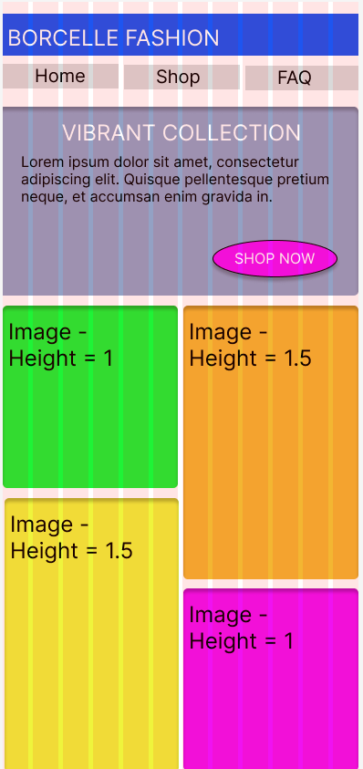 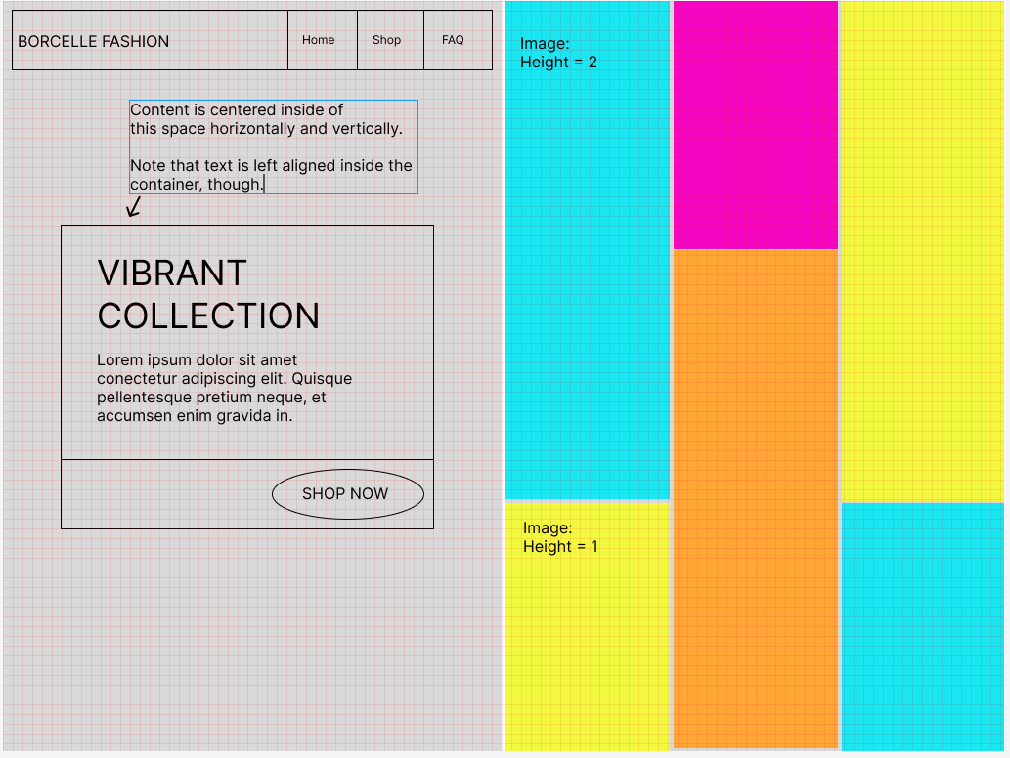
  3. Create a folder named *yourLastName-hw02* on your computer.
  4. Inside the folder, create the HTML and CSS needed to build the Borcelle Fashion page.
     1. Your HTML should
        1. be valid, of course, and follow all our typical coding conventions.
        2. Make good use of the semantic markup tags to identify the sections that you might need.
        3. Contain a viewport meta tag so that mobile browsers do not automatically “zoom out” to show the entirety of the page
     2. In your CSS file, use any combination of CSS grid or flexbox techniques to create a design that:
        1. is mobile-first
           + create the CSS needed to style the raw HTML into the mobile design first, then add media queries as needed to convert it into the desktop design for browsers with a width > 600 px
        2. is a reasonable match for the mobile and desktop wireframes above. The page layout should shift when the width is 601 px or larger.
           + Note that you do not need to worry much about the colors or finding perfect image matches. I’ll put a folder of sample images on Moodle that you may download if you like.
           + You should have the image proportions correct, however. They images should have **about** 50% of the space in the mobile design and a third of the space in the desktop design. The height of the tall images in the mobile design should be 1.5 times the height of the short images. In the desktop design, the height of the tall images should be twice the height as the short images.

Hint: Get the containers of the images the right dimensions, first, and then explore how to make the [images fill the available space](https://sentry.io/answers/how-do-i-auto-resize-an-image-to-fit-a-div-container/)

* 1. Test your page for the final time in the browser, confirming that it performs as expected in both a mobile view (600px and under) and traditional desktop view. Upload your zipped folder to the appropriate submission area in Moodle.